Ex:No: 17
Date:

Aim:

HIGH LEVEL PROGRAMMING EXTENSIONS-FUNCTIONS

To implement Functions using program in MySQL.

Functions:
A function is a subprogram that computes a value.

Creating a function
The CREATE FUNCTION statement is also used in MySQL to support UDFs (user-defined functions). A UDF can be regarded as an external stored function.

MySQL stored function syntax
CREATE FUNCTION function_name(parameter1, parameter2, ...)
RETURNS datatype
DETERMINISTIC
BEGIN
statements;
RETURN value;
END;

Problem 1:
Create a function that returns the level of a customer based on credit limit. (Use the IF statement to determine the credit limit).
If credit limit > 50000 then customer_level = PLATINUM
If credit limit >= 10000 AND credit limit <= 50000 then customer_level = GOLD If credit limit credit limit < 10000 then customer_level = SILVER

RECURSION in Mysql Procedures Mysql version should be >= 5.
Have to set system parameters. This means putting the recursion count limit. SET @@GLOBAL.max_sp_recursion_depth = 255;
SET @@session.max_sp_recursion_depth = 255;

Problem 2
Write a recursive MySQL procedure to compute the factorial of a number. The manual also notes that recursion requires an appropriate recursion-depth setting

Program- 1:

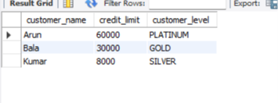

Program- 2:
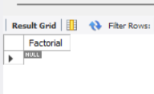

RESULT: Thus the Functions using program in MySQL executed successfully .

